CS 340 README Tyler spitz 6-18-26

About the Project/Project Title

Using a Dash based interface this project organizes data for Grazioso Salvare rescue animal training company for identifying certain animals via a given criterion.

Motivation

The purpose of this project is to provide Grazioso Salvare with an interactive tool for identifying sheltered animals within a certain criterion. This includes Mountain, Water, and Disaster rescue training. Utilizing a MongoDB database this provides real time filtering and mapped locations for animals.

Getting Started

For locally running this project you will need MongoDB running along with the imported aac database of the animals collection. The CRUD Python Module file will also be needed.
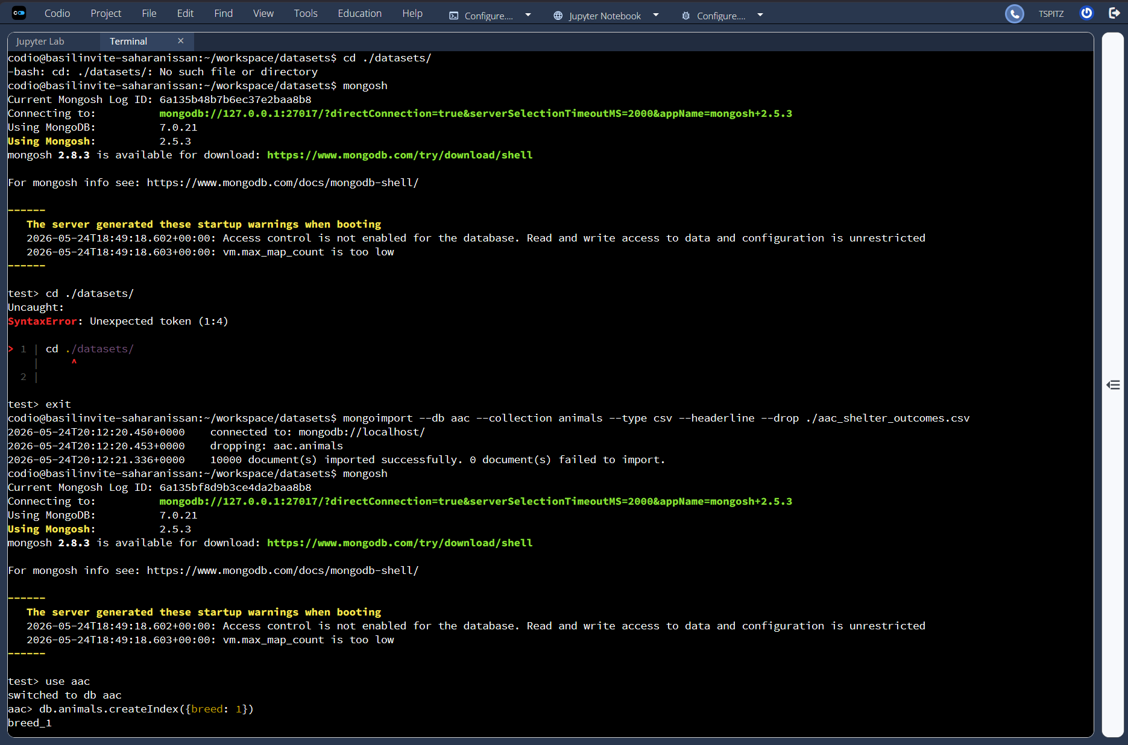

Installation

Tools used for this software include:
Python
PyMongo
MongodDB
Jupyter Lab
Pandas
Plotly express
Dash

Usage

Open the ProjectTwoDashboard.ipynb file in Jupyter Lab and run all cells. The dashboard will launch with a printed URL.

Code Example

from CRUD_Python_Module import AnimalShelter
from jupyter_dash import JupyterDash

username = “aacuser”
password = “yourpassword”
db = AnimalShelter(username,password)

#Read all Animals
import pandas as pd
df = pd.DataFrame.from_records(db.read({}))
df.drop(columns=[“_id”],inplace=True)

Tests

You can use Jupyter Lab to run the .ipynb file to test the dashboard functionality. Various Radio Buttons have been implemented to assist with filtering. Use the radio buttons to verify that the correct breeds and sex criteria are displayed. You can then select individual animals to update the map location.

Screenshots : Dashboard Functionality
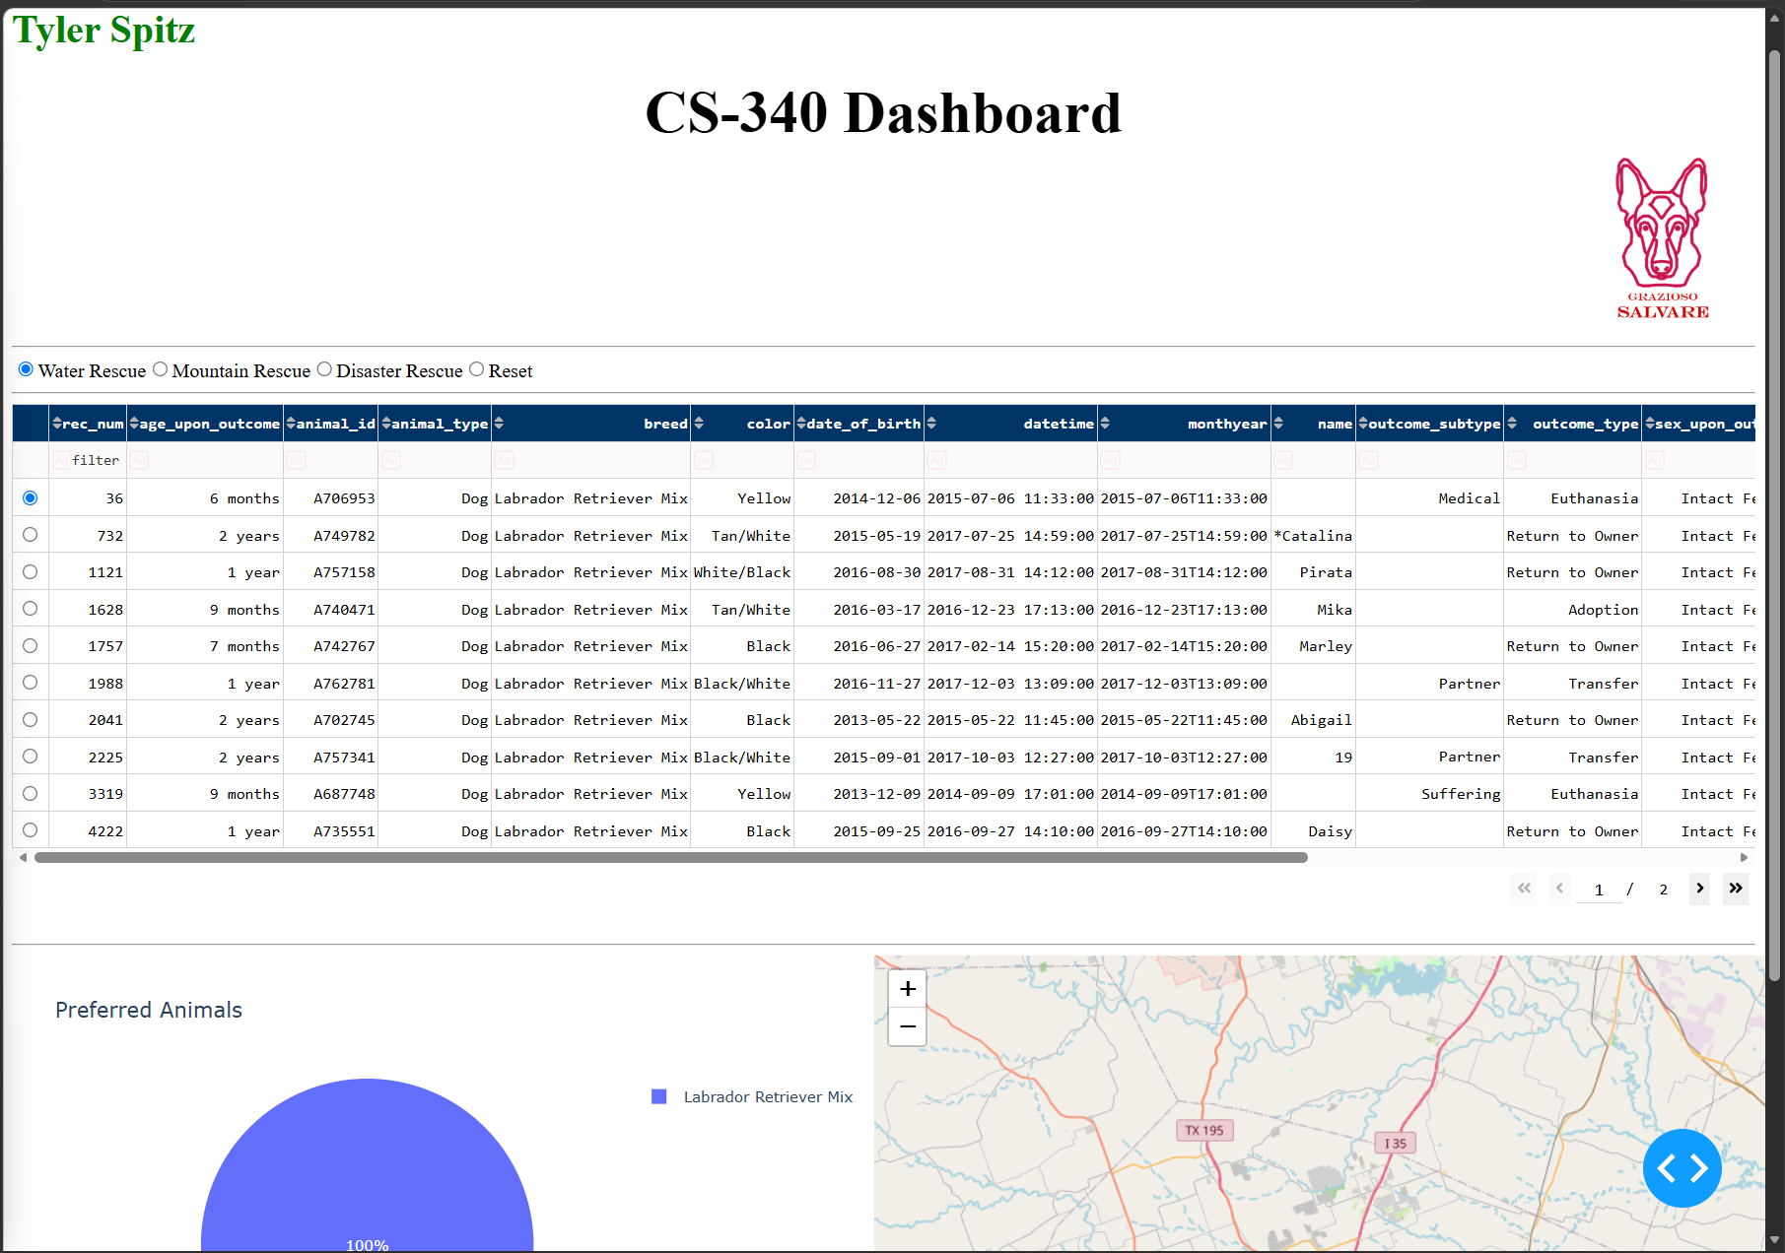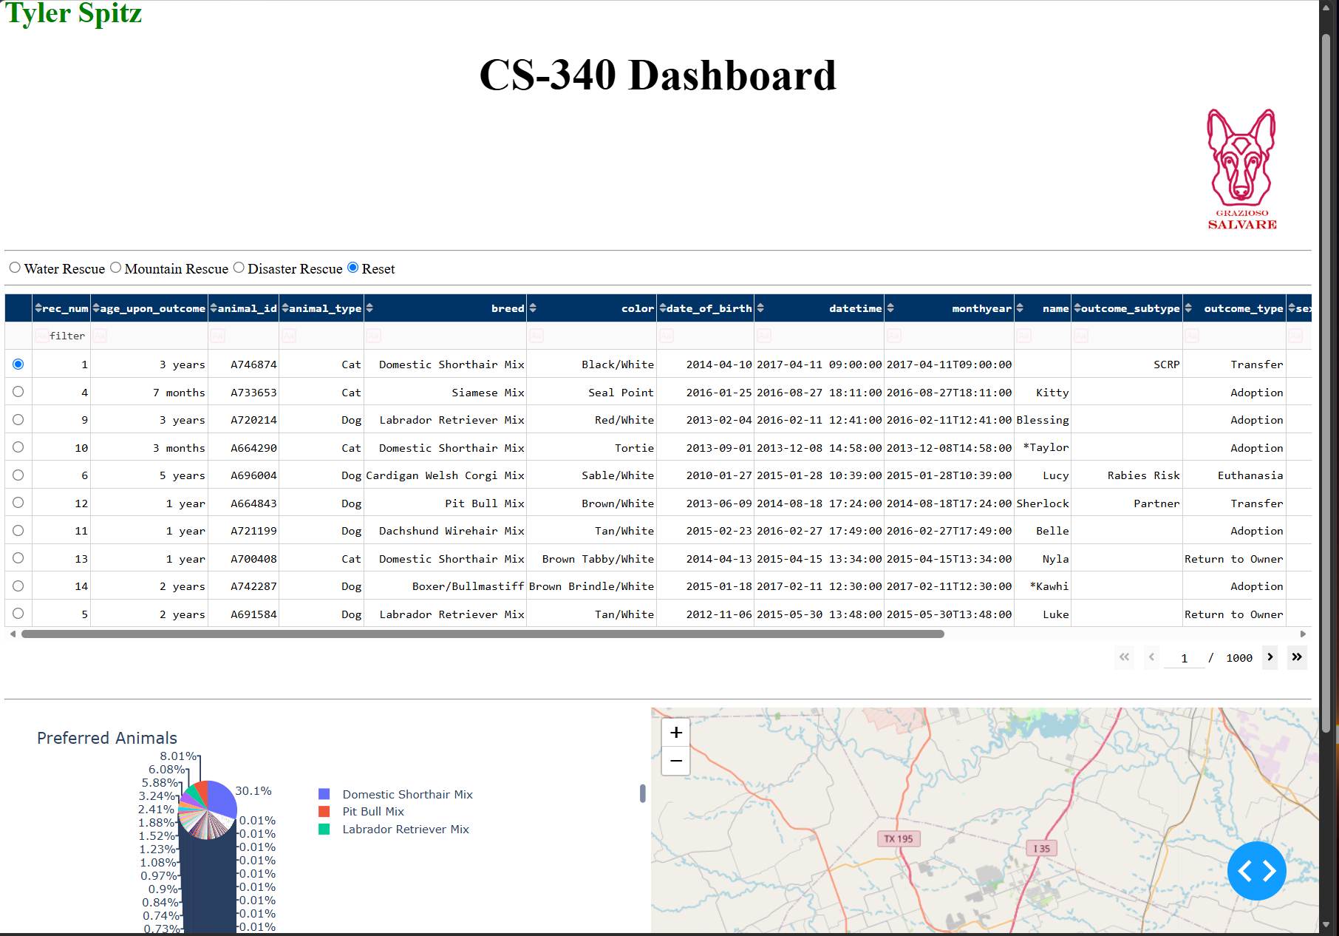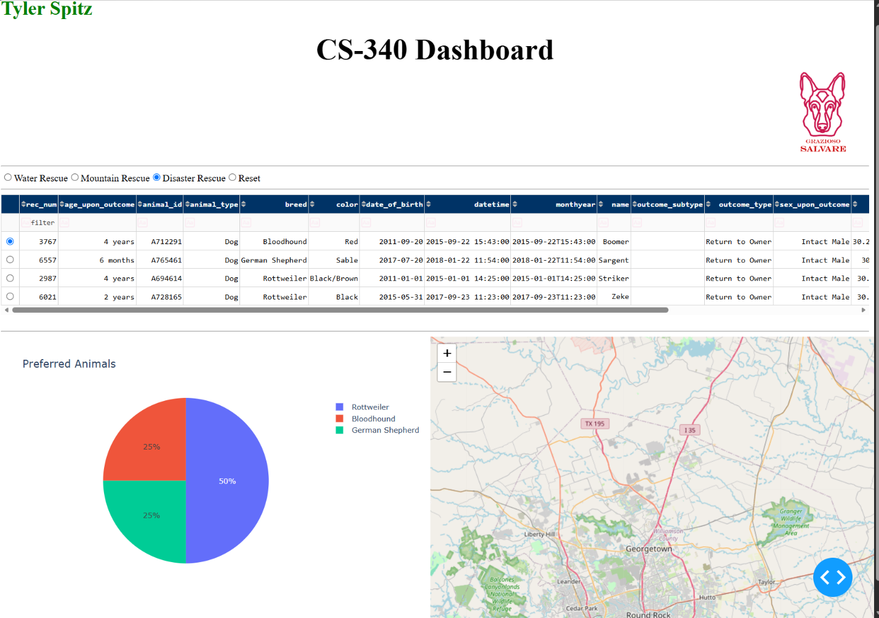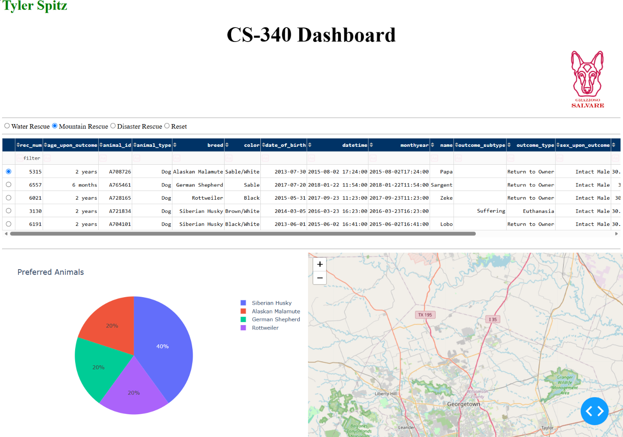

Tools
MongoDB was selected for this project as the database layer due its compatibility with Python. The document-based model works directly with Python dictionaries and Pandas DataFrames making a streamlined process to load query results. $in, $gte, and $lte proved essential for the projects rescue-type filtering features.
Dash framework was used to display the view and controller layers. The callback system is used to wire inputs from the radio buttons directly with the python functions. This reactive model keeps the interface up to date without page reloads.

Process
The process for completing the project involved numerous steps. Setting up MongoDB and importing the animals dataset. This involved creating a aacuser with read access. The CRUD module was then developed for create, read, update, and delete functionality. Connection of the CRUD module was established to the Dash dashboard and records were loaded into the Pandas DataFrame. Sorting, filtering, and single row selection were then implemented as features. Radio button controls were then wired to MongoDB queries. Pie chart and callback functionality were implemented. The geolocation map callback was built to show animal coordinates. Finally the company’s logo was added to the upper right along with the styled name and header.

Challenges
The logo was initially not appearing and was discovered I had the HTML element defined outside of the app.layout so it was never rendered. Moved the element within the layout DIV resolved this issue.

The update_dashboard callback was returning (data,columns) which Dash threw and error expecting an Object but received an array. The fix I found was to only return data.

The update_styles callback crashed with a NoneType error when no column was selected. I added a small guard at the top of the function to return an empty list in that case.

The update_map callback threw an IndexError when selecting different filters due to the previous row index exceeding the length of the new filtered dataset. Added a check to fall back to row 0 if the index was out of range.

Contact
Your name:
Tyler Spitz

